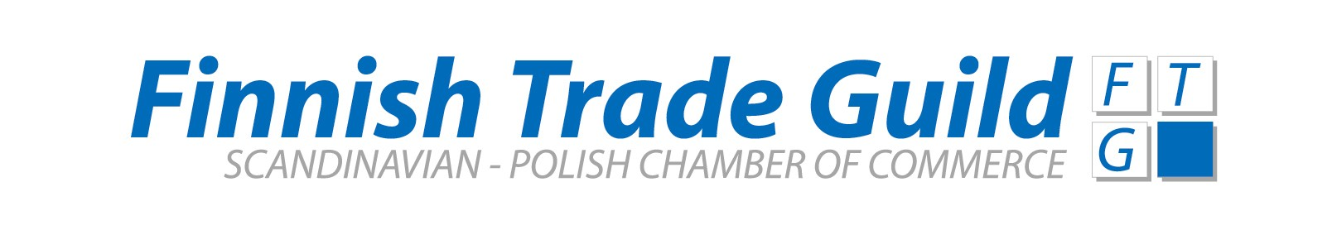
October 10th 2007
The Finnish Company of the Year in Poland – Award

Nordkalk Sp. z o.o. was chosen as “The Finnish Company of the Year in Poland 2006”.

The Finnish Trade Guild and Finpro are now opening the 2007 edition of the award. If your company is interested in participating or you would like to nominate a business that you believe should be recognized, kindly fill in the application form below and send it via email or fax to Finpro Poland by the 15.11.2007 e-mail: maria.onikki-gorski@finpro.fi fax +48 22 621 6394.

The rules and eligibility criteria are enclosed. For more information, please contact Maria Onikki-Górski, Finpro Poland, phone + 48 22 625 68 65.

Application Form

I am pleased to nominate the (company) ………………….…………………for the Award

Please fill out the table and the questions below. In request please be prepared to send supporting financial statements for fiscal years 2005 and 2006.

- Company name: ___________________________________________

- Legal status: ___________________________________________

- Type of business
(Production, sales, services): ___________________________________________

4. Description of core business: ___________________________________________

_______________________________________________________________________________

5. Year of establishment in Poland: ___________________________________________

6. Company locations in Poland: ___________________________________________

7. Finnish ownership in % of total: ___________________________________________

- Why is this company a good candidate for the Award (please review the selection criteria and tell briefly in your own words how the company has fulfilled the criteria in terms of visibility – profitability – growth – sustainability - business development - innovation):

__________________________________________________________________________________________________

__________________________________________________________________________________________________

__________________________________________________________________________________________________

__________________________________________________________________________________________________

__________________________________________________________________________________________________

__________________________________________________________________________________________________

Please insert figures into the table

 | Total Investments  (million PLN) | Divestments  sale of parts/ whole companies | Employees  (number) | Turnover  (million PLN) | Net Profit  (million PLN) | Est. market share in % | Growth in %  to previous years(s)
Year end 2005*

Year end 2006*

First half year 2007*

*Please indicate above if fiscal year if fiscal year does not follow calendar year.

Name and contact data:

________________________________________________________________________________

Appendix “The Finnish Company of the Year in Poland” – Award

Definition and Background
- The Award is an annually granted recognition to a Finnish company operating in Poland.
- Eligibility: All Finnish companies having an established legal entity in Poland. A company is considered Finnish if it has minimum 50% Finnish ownership or if the initial investment originates from Finland and the company has its roots and a permanent office in Finland.
- The tradition has been started to commemorate Finnish Trade Guild’s (FTG’s) 10th operational year in Poland in 2004 and it has been initiated in cooperation with and with support from Finpro Poland.

Objective
- To recognize the work and the achievements of Finnish companies in Poland and to honor the contribution of employees involved.

Stakeholders
- Finnish companies operating in Poland: see eligibility criteria below.
- Finpro Poland: screening and evaluating the companies and their data, sharing the screening results with FTG board and co-organizing the award giving ceremony.
- FTG board: selecting the awarded company and organizing the award giving ceremony.
- The Finnish Ambassador: giving the award and honoring the ceremony as its Patron.

Selection criteria
- Positive visibility and active participation in the market and/or society (via promotion and/ or via contributions to local society preferably promoting Finnish expertise);
- Business success during the last three (3) fiscal years in terms of Profitability and/or Market share and/or Growth (verified preferably via financial statements);
- Sustainable business practices that are fully compliant with all applicable laws and regulations, no reported involvement in scandals;
- Ability to carry out challenging Business Development processes (own business case).

Selection process
- Finpro will send information and application form on the award to Finnish companies in Poland in October.
- Companies should fill out and send the applications to Finpro by 15th of November. A company may also be proposed and justifications provided by a third party.
- Finpro will evaluate the applications and provide FTG board an evaluation of the short-listed candidates versus selection criteria by the end of November.
- FTG board will meet in January, select the award winner and announce it January/ February in connection with the FTG annual meeting, or another suitable event.

