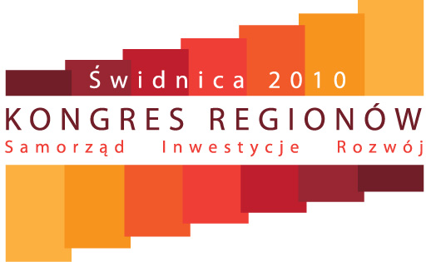

The Schedule:

May 19th, 2010 – guests gradual arrival in the afternoon

8 p.m. – welcoming reception

May 20th, 2010

9 a.m. – 11 a.m. – plenary session: 20th anniversary of local government
11 a.m. – 5 p.m. – panel discussions conducted simultaneously in 10 conference halls, one panel discussion will last 1 hr 15 min + a 15-minute break
5 p.m. – 7 p.m. – plenary session: Poland 2030 vs local government
9 p.m. – social events, receptions, concerts, etc.

May 21st, 2010

9 a.m. – 11 a.m. – plenary session: Special Economic Zones after 15 years of existence – successful combination of investors expectations and the expectations of individual regions?
11 a.m. – 5 p.m. – panel discussions conducted simultaneously in 10 conference halls, one panel discussion will last 1 hr 15 min + a 15-minute break
5 p.m. – 7 p.m. – plenary session: Party dependency of the local government - harmless myth or harmful reality?
9 p.m. – social events, receptions, concerts, etc.

May 22nd, 2010

cultural events in the market square, reconstructions of historic battles, etc.

