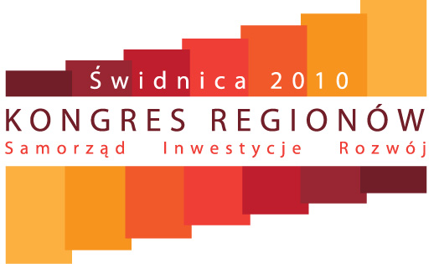

We would like to kindly inform you that May 19th-22nd, 2010 in the city of Świdnica we will convene the National Congress of Regions that will centre around three major issues:

LOCAL GOVERNMENTS, INVESTMENTS, DEVELOPMENT

It will be a unique place where businessmen, entrepreneurs and investors will be able to meet the representatives of local authorities. A number of panel discussions, workshops and commercial presentations will take place at the Congress.

In May 2010 the Polish edition of “Forbes” magazine, one of the press titles that organizes the Congress, will publish its annual ranking of cities and districts that are most investor-friendly. Winners will be presented with awards at the Congress of Regions. We also believe it will be a good moment to meet the mayors who most eagerly seek investors for their own regions.
The following Awards will be also presented at the Congress:
- N15 – Ranking of the 15 best mayors according to Newsweek Polska
- Ranking of the best provinces, counties and cities in the year 2009 according to the methodology of the Association of Polish Counties.
In the Congress programme we will include a wide choice of topics that may attract your interest.
The topics are divided into six blocks according to the competence of Axel Springer Polska press titles:
- NEWSWEEK – politics, systems of local governments, relations between the government and the local authorities
- FORBES – business, investments, financing and funding
- FAKT – citizen vs. office, whether offices are citizen-friendly
- AUTO ŚWIAT - public communications, roads, the automotive industry
- KOMPUTER ŚWIAT - e-office, e-citizen, local government in the XXI century
- PRZEGLĄD SPORTOWY - sports, sports clubs, Euro 2012

Please, find attached the details of the project together with its factual description.
Yours sincerely,

Andrzej Stepanów

Director of Corporate Marketing
Axel Springer Polska Sp. z o. o.

More information: www.kongresregionow.pl and kongresregionow@biznesmolo.pl

